GR 1 FUNDAMENTAL AERO EQUATIONS

Equation Name Assumptions

P = ρ R T Perfect Gas Law* Perfect Gas

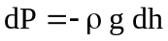 Hydrostatic Equation Static Fluid

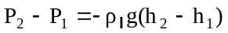 Manometer Equation Incompressible, Gravity is constant (small Δh)

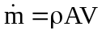 Mass Flow Equation* 1-D

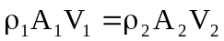 Continuity Equation* 1-D, Steady

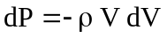 Euler’s Equation Steady, Along a Streamline, Inviscid, No Body Forces
Airspeed where compressible flow effects must be considered is above 330 ft/s (100 m/s, 225 mph, M=0.3)
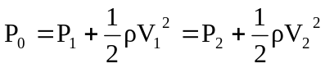 Bernoulli’s Equation* Same as above and Incompressible
q = ½ ρ V² Dynamic Pressure* None
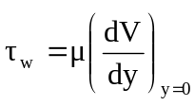 Shear Stress None
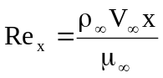 Reynold’s # of x None
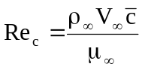 Chord based Reynold’s # None
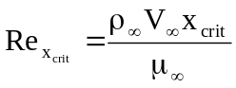 Critical Reynold’s # None
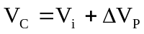 Calibrated Air Speed None
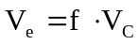 Equivalent Air Speed None
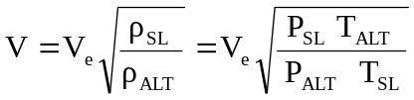 True Air Speed None
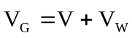 Ground Speed None
AR =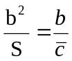 Aspect Ratio* None
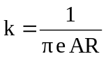 Drag due to Lift Factor None

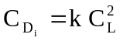 Induced Drag Coefficient None

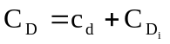 3-D Drag Coefficient None
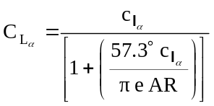 3-D Lift Curve Slope None
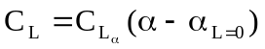 3-D Lift Coefficient None
L = C_{L} q S 3-D Lift* None

D = C_{D} q S 3-D Drag* None

M = C_{M} q Sc 3-D Pitching Moment* None
Equation Name Assumptions
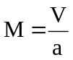 Mach Number* None
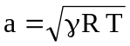 Speed of sound None
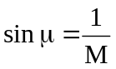 Mach Angle None

C_{D} = C_{Do} + k C_{L}² Aircraft drag polar* None

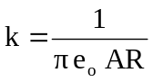 “drag due to lift” factor* None

P = T V Power to thrust* None

R = E V Range to endurance* None
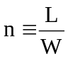 Load Factor None
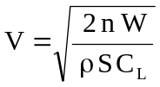 Velocity at any C_{L} SLUF or SLF
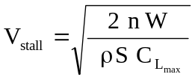 Stall Velocity SLUF or SLF
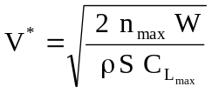 Corner Velocity None

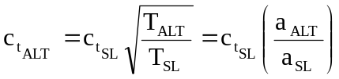 TSFC Alt Conversion None

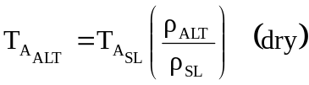 Thrust (mil) Alt Conv None
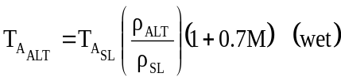 Thrust (max) Alt Conv None

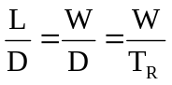 L, D, T_{R}, Wt relationships SLUF
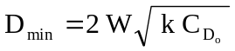 Minimum Drag SLUF at (^{L}/_{D})_{max}
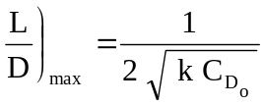 (^{L}/_{D})_{max} w/ Drag Polar SLUF at (^{L}/_{D})_{max}
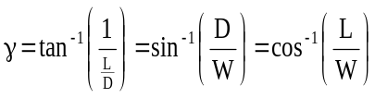 Glide angle relationships Gliding Flight, SUF
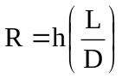 Glider Range Gliding Flight, SUF
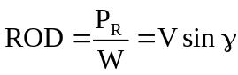 Glider Vertical Velocity Gliding Flight, SUF
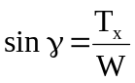 Climb angle relationship Climbing Flight, SUF

Equation Name Assumptions

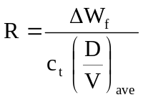 Average Range Eqn SLUF
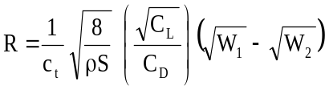 Breguet Range Eqn SLUF
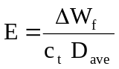 Average Endurance Eqn SLUF
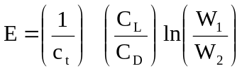 Breguet Endurance Eqn SLUF
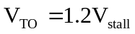 Take-off Velocity None
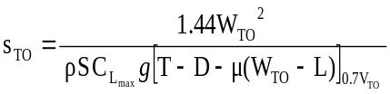 Take-off Distance None
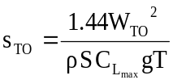 Take-off Distance Thrust >> retarding forces
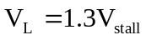 Landing Velocity None
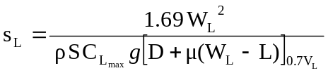 Landing Distance No thrust reversers
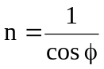 Load Factor SLF
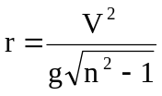 Steady Lvl Turn Radius SLF
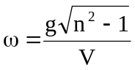 Steady Lvl Turn Rate SLF
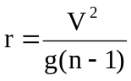 Pull-up Turn Radius Instantaneous Pull-up
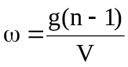 Pull-up Turn Rate Instantaneous Pull-up
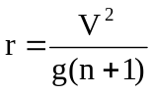 Pull-down Turn Radius Instantaneous Pull-down
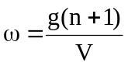 Pull-down Turn Rate Instantaneous Pull-down
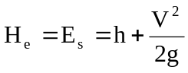 Energy Height SLUF
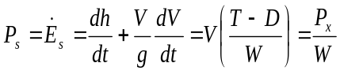 Specific Excess Power None

